Claiming Staff Expenses via U4ERP.
General information
Staff will be reimbursed for business travel and any expenses incurred wholly, necessarily and exclusively in the performance of their duties, however, staff should be prudent in incurring expenditure when on University business. View the ‘Staff Travel and Expenses Policy’ [HERE].

- Email [financesystem@hope.ac.uk] to request U4ERP expenses access.
- Individuals must enter their own claims. Expenses are paid to the user logged into the system.
- Amounts are to be entered in GBP, with other currencies converted to GBP. The conversion rate used should be shown in ‘Product text/Description’. Receipts must be attached to fully support all claims.
- The Budget Holder is responsible for ensuring that claims comply with the expenses policy, including validation of pre-determined rates (e.g. mileage), amounts claimed, and correct receipts attached.
- When a claim is fully approved the claimant will receive email confirmation of the amount due.
- Rejected claim lines must be resubmitted, or cancelled, by the user. PAYMENT cannot be made for any part of the claim while rejected lines are outstanding. (see instructions at end)
- Approved claims are paid in the next payroll run. The cut-off date for inclusion is on [or around] the 8th of the month. Items approved after the cut off will be paid in the following month.

Expenses Entry Screen - To enter new lines, click Add or click anywhere under requisition details
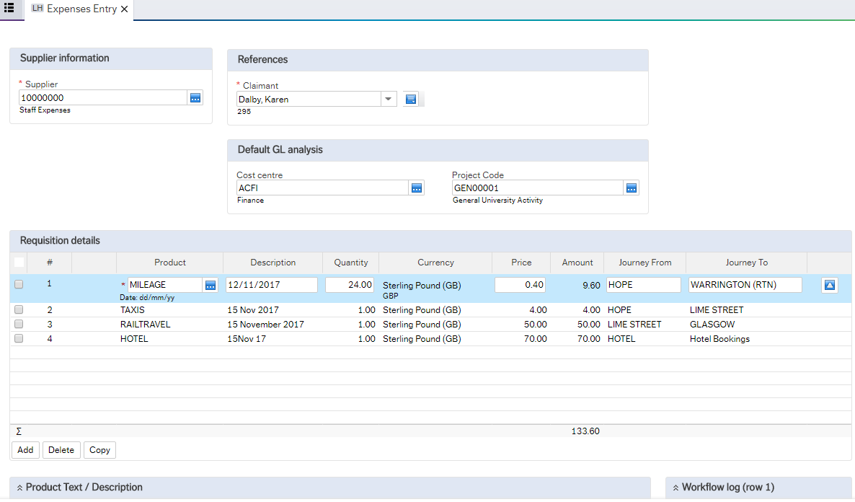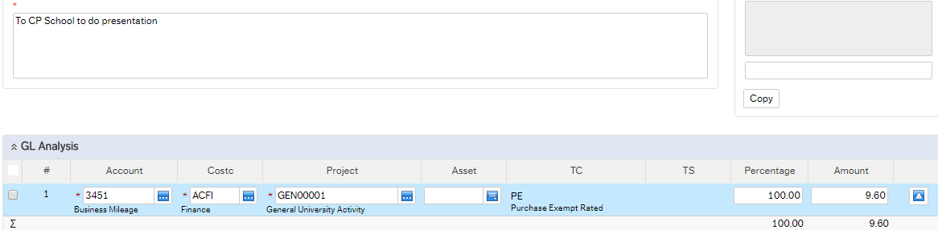

Use appropriate product code (type ahead for range of codes [see list at end])
For EACH line a description MUST be entered here
(line must be selected / blue)
Enter date
(DD/MM/YY)
MILEAGE Claims
enter miles here
For ALL journeys enter ‘From & To’. (Identify returns (RTN)
Expenses will be coded to your default codes
(This should be changed in GL Analysis [end of page] if the expense is funded from another code)

Must use supplier 10000000 for staff expenses
MILEAGE default Rate shown here
DO NOT CHANGE

(If required) Select line to be coded and make changes here
Non-mileage claims
Enter quantity and price

ABCD

ABCD
This section may populate with default codes
This will need to be changed if the expenses are being claimed from a different cost centre or project (see your admin support)

Attaching documents in Unit 4

** Prepare your supporting documents before starting your claim **

✓PDF is the best format for documents.

✗Photo images cannot be uploaded to U4.

- Receipts can be scanned from a printer and sent to your email as a PDF
(if necessary check this with the relevant admin team).

- Alternatively
- Take photos using a mobile phone
- Screenshot the images to a word document
  - Amend the images to fit approx. 4 per page
- Save the word document as a PDF file
  - File > Save As
  - Select the appropriate folder
  - Save as Type > Select PDF from the drop-down list
  - Save

If necessary the PDF file(s) can be saved as a reduced size

- Open the PDF
- Select File > Save as Other > Reduce File Size
- Save

OR
- Open the PDF
- Select File > 'Save as'
- Under 'File Options' tick 'Reduce File Size'
- Save

- Entering Expenses: The expenses entry screen is in Procurement > Expenses Entry.
Enter the following information: (*mandatory fields)
Supplier Information
* Supplier | 10000000 (7 zeros) Staff Expenses - Always use this value
References
* Claimant | Check that this is your name and payroll ID (The payment will be made to THIS USER, if this is incorrect Contact financesystem@hope.ac.uk.
Default GL Analysis
These fields are mandatory and should be completed before entering details lines
(Contact your Admin Team or Budget Holder for correct codes)
Cost Centre | This may be pre-populated with a DEFAULT cost centre.  This can be entered manually, or changed if the expenses are being funded by a different cost centre
Project Code | Enter an 8-digit project code from which the expenses are to be deducted.
To add lines, click on any line below the ‘Requisition details’ headers.
Requisition Details
* Product | An alphabetic code that corresponds to a numerical account code.  (See 3. Commonly used product codes)
Description | Defaults to the product description…  … But must be OVERTYPED with the DATE of travel or expense. (DD/MM/YY)
Quantity | MILEAGE - enter the number of miles to be claimed.  OTHER - leave as 1 unless claiming >1 of the same item.
Currency | GBP/fixed. Other currencies to be converted to GBP. The conversion rate used should shown in ‘Product text/Description’, or marked clearly on the receipts
Price | Price per item (for ‘Mileage’ this populates with the default value)
Amount | Quantity x price = amount to be paid (subject to approval).  No VAT will be added to the payment.
Journey From & To | For all travel (whatever mode), enter START and END location (post code)  (For ‘non-journey’ items leave BLANK)
* Product Text / Description (claim will not save if this box is blank)
For EACH LINE on the claim explain the reason for incurring the expense e.g. lunch at meeting, attending a conference, location of expense etc. If this is omitted from any line, the claim will not save!
GL Analysis
Account | Defaults to the corresponding account code for the product selected
Cost Centre | - Default values as per ‘Default GL analysis’ (top of the screen)  - Cost Centre and/or Project can be changed per line if required. Ensure relevant line is selected before making changes.
Project
Asset, TC, TS | Not applicable
Percentage | Do Not Use
Amount

- Commonly used product codes.
(This list is not exhaustive, for further information contact your Department/School admin support.)
Product code | Description | Account code | Comment
TAXIS | Taxis | 2011
*MILEAGE | Mileage | 3451 | Rate varies depending on mode of travel  Price will default to the correct rate per mile  Mileage+1: when carrying 1 or more passengers  Mileage CYCL: for bicycles  Mileage MCYC: for motorcycles
*CARHIRE | Car Hire | 3454 | The University’s approved provider should be used, other than in exceptional circumstances.
COURSE&CONF | Courses & Conferences | 2007
SUBSISTENCE | Subsistence | 3455
HOTEL | Hotel | 3456 | Hotels, air & rail travel should be booked using the University’s Travel Management Company, other than in exceptional circumstances.
AIRTRAVEL | Air Travel | 3452
RAILTRAVEL | Rail Travel | 3453
GENTRAVELEXP | General Travel | 3450 | To be used ONLY for travel items not available above (e.g. car park fees)

* Before you Drive - you must be authorised to drive a motor vehicle owned, hired or leased by the University on university business by completing a Driver Declaration Form. This includes staff who are required to drive University vehicles as an essential part of their work (e.g. Estates, Catering, Student Support and Well-being and Campus Support staff) and those who either hire a vehicle or chose to use their own private vehicle on University business. The Driver Declaration Form and Driving at Work Code of Practice can be found [HERE].

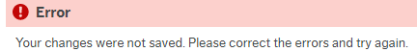
- Fault Finding:
There are two main errors that prevent a claim from saving.

  - INVALID PRODUCT
- This error message will be displayed when an invalid code is entered.
- Change the product before moving on. When a valid product is entered the error message will disappear. See 3.0 Commonly used product codes.

  - TEXT MISSING in the PRODUCT TEXT / DESCRIPTION field
- The error message will be displayed when save is selected.
- Select each line in order. The ‘offending’ lines will display the error message and the box will turn red.

- To avoid claims being rejected please ensure the following
  - Cost centre, project and product are correct
  - Mileage is claimed against product Mileage or Mileage+1
  - Receipts are attached

- Receipts
Prepare documents prior to entering the claim. To attach receipts, click on the paperclip icon in the top right-hand corner of the screen. Click on ‘Add a Document’ and ‘Upload’ to locate the file to be uploaded. Click on ‘Save’. Exit the documents screen by the ‘X’ in the top right-hand corner. Attach receipts before saving the claim. Receipts are attached to the full claim, not to individual lines.
✓PDF is the best format for documents. ✗Photo images cannot be uploaded to U4.
(See page 2 ‘Attaching documents in Unit 4’)

- Submit Claim
Click on Save when all lines have been entered and all receipts attached. The claim will be distributed to the relevant budget holder(s) and cannot be changed. Once approved a confirmation email is sent to the claimant. The cut-off date for inclusion is on [or around] the 8th of the month. Items approved after the cut off will be paid in the following month.

Rejected Expenses
The Budget Holder will check the expense claim to ensure compliance with University policies including validation of pre-determined rates (e.g. mileage), amounts claimed, and correct receipts attached.
In the event of errors, or queries against a claim, some or all lines may be rejected, either as an outright rejection or to request amendments or further information.

If any lines of the claim are rejected, the user will receive an email with the message 'The following requisitions have been assigned to you [details of rejected line(s)] Please log into U4ERP or use the link below to action the required tasks’

*** DO NOT IGNORE THIS!
Approved items WILL NOT be paid until the rejected line(s) have been processed
(CANCEL or RESUBMIT for approval - see below) ***

Log into U4ERP to view outstanding tasks. There will be a red/orange number, alongside a tick, in the top right-hand corner of the screen. This is the number of tasks requiring action. Click on a task to open it. The workflow log, top right of the window, will show the reason for the rejection. For multiple lines, click on each line to view the reason.

At this point, there are 2 options:
- Resubmit the expense claim or line(s) to return to the budget holder(s) for approval
- Cancel this line so it is removed from the claim. Payments will be made, to include only the approved lines.
Lines can be cancelled or resubmitted at the same time, but all lines require a comment to explain the action taken. When actioning multiple lines, click on each line in turn to enter a comment for the line. Receipts can also be added at this point.

- Click on the line to be action (so it is blue) and then click on either ‘resubmit expense claim’ or ‘cancel expense claim’. Enter a comment in the workflow log to explain why this is being resubmitted or cancelled. Repeat if there are multiple lines to resubmit or cancel. When all lines have been actioned, click on the SAVE button further down the screen. (see screenshot over page)
Screen shots: Rejected expense claim Cancel or resubmit
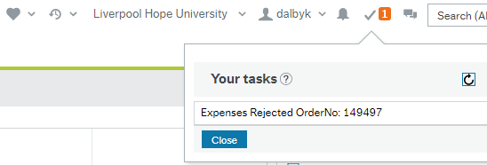
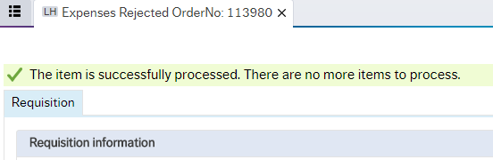
Enter a comment here (for multiple lines click COPY or select each line to enter comment separately)
Click 'Save'
Error message
(e.g. comment not entered)
Action successful
Select 'Cancel Expenses Claim' OR 'Resubmit expense claim' (as required) For multiple lines tick box before selecting the action
The reason for rejection will show here (for multiple lines click on each line to see reason)
Look for tasks here. The number indicates number of individual tasks.
Click on the number to see the task list.
Click on a task to look at the detail.
(if any lines are rejected an email alert will be sent to the user)
To Amend Coding
Select the line to be amended
Amend coding in the GL Analysis
Do this for each line as required
Resubmit and Save

ABCD

